**Target Case Study**

# Data type of all columns in the "customers" table.

# Assuming customers table already exists in the database

SELECT column_name, data_type

FROM target_sales_2016_2018.INFORMATION_SCHEMA.COLUMNS

WHERE table_name = 'customers';

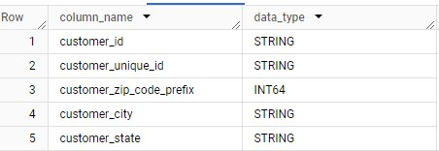

# Get the time range between which the orders were placed.

# Count the Cities & States of customers who ordered during the given period.

SELECT

  MIN(order_purchase_timestamp) AS start_date,

  MAX(order_purchase_timestamp) AS end_date

FROM target_sales_2016_2018.orders;

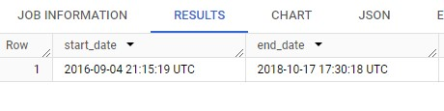

SELECT

  COUNT(DISTINCT customer_city) AS num_cities,

  COUNT(DISTINCT customer_state) AS num_states

FROM target_sales_2016_2018.customers

WHERE customer_id IN

  (SELECT DISTINCT customer_id

  FROM target_sales_2016_2018.orders

  );

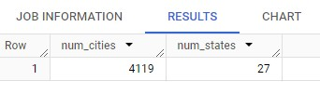

# In-depth Exploration:

# Is there a growing trend in the no. of orders placed over the past years?

SELECT

  EXTRACT(YEAR FROM order_purchase_timestamp) AS order_year,

  COUNT(*) AS num_orders

FROM target_sales_2016_2018.orders

GROUP BY order_year

ORDER BY order_year;

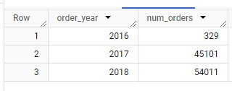

Inference: Yes, there has been major growth from 2016-17, then a small growth from 2017-18.

# Can we see some kind of monthly seasonality in terms of the no. of orders being placed?

SELECT EXTRACT(MONTH FROM order_purchase_timestamp) AS order_month,

       COUNT(*) AS num_orders

FROM target_sales_2016_2018.orders

GROUP BY order_month

ORDER BY order_month;

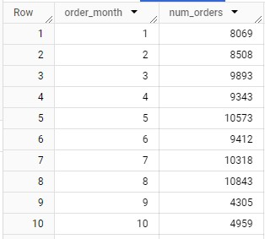

Inference: From the results we can infer that peak seasons were mid-years May-Aug, Weak seasons were end of the year Sep-Dec.

# During what time of the day, do the Brazilian customers mostly place their orders? (Dawn, Morning, Afternoon or Night)

# 0-6 hrs : Dawn

# 7-12 hrs : Mornings

# 13-18 hrs : Afternoon

# 19-23 hrs : Night

SELECT

    CASE

        WHEN EXTRACT(HOUR FROM order_purchase_timestamp) BETWEEN 0 AND 6 THEN 'Dawn'

        WHEN EXTRACT(HOUR FROM order_purchase_timestamp) BETWEEN 7 AND 12 THEN 'Morning'

        WHEN EXTRACT(HOUR FROM order_purchase_timestamp) BETWEEN 13 AND 18 THEN 'Afternoon'

        ELSE 'Night'

    END AS order_time_of_day,

    COUNT(*) AS num_orders

FROM target_sales_2016_2018.orders

GROUP BY order_time_of_day

ORDER BY num_orders DESC;

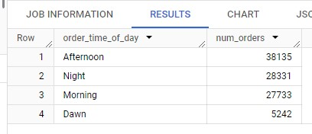

Inference: Most of the orders were placed during Afternoon time.

# Evolution of E-commerce orders in the Brazil region:

# Get the month on month no. of orders placed in each state.

SELECT

  EXTRACT(MONTH FROM o.order_purchase_timestamp) AS order_month,

  c.customer_state,

  COUNT(*) AS num_orders

FROM target_sales_2016_2018.orders o

JOIN target_sales_2016_2018.customers c ON o.customer_id = c.customer_id

GROUP BY order_month, c.customer_state

ORDER BY order_month, c.customer_state;

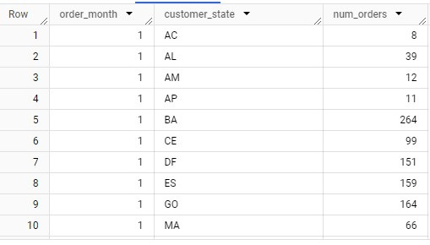

# How are the customers distributed across all the states?

SELECT customer_state,

       COUNT(DISTINCT customer_id) AS num_customers

FROM target_sales_2016_2018.customers

GROUP BY customer_state

ORDER BY num_customers DESC;

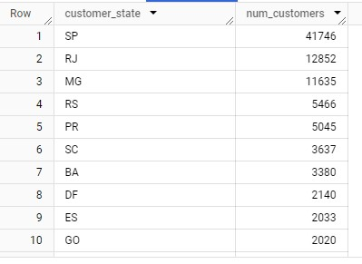

Inference: State São Paulo (SP) has the most customers, while state Roraima (RR) has the least customer base.

# Impact on Economy: Analyze the money movement by e-commerce by looking at order prices, freight and others.

# Get the % increase in the cost of orders from year 2017 to 2018 (include months between Jan to Aug only).

WITH order_costs_2017 AS (

    SELECT EXTRACT(YEAR FROM o.order_purchase_timestamp) AS order_year,

           EXTRACT(MONTH FROM o.order_purchase_timestamp) AS order_month,

           SUM(p.payment_value) AS total_payment_value

    FROM target_sales_2016_2018.orders o

    JOIN target_sales_2016_2018.payments p ON o.order_id = p.order_id

    WHERE EXTRACT(YEAR FROM o.order_purchase_timestamp)=2017

      AND EXTRACT(MONTH FROM o.order_purchase_timestamp) BETWEEN 1 AND 8

    GROUP BY order_year, order_month

), order_costs_2018 AS (

    SELECT EXTRACT(YEAR FROM o.order_purchase_timestamp) AS order_year,

           EXTRACT(MONTH FROM o.order_purchase_timestamp) AS order_month,

           SUM(p.payment_value) AS total_payment_value

    FROM target_sales_2016_2018.orders o

    JOIN target_sales_2016_2018.payments p ON o.order_id = p.order_id

    WHERE EXTRACT(YEAR FROM o.order_purchase_timestamp)=2018

      AND EXTRACT(MONTH FROM o.order_purchase_timestamp) BETWEEN 1 AND 8

    GROUP BY order_year, order_month

)

SELECT

  order_costs_2017.order_month as month,

  (order_costs_2018.total_payment_value - order_costs_2017.total_payment_value) / order_costs_2017.total_payment_value * 100 AS percentage_increase

FROM order_costs_2017

JOIN order_costs_2018 ON

order_costs_2017.order_month = order_costs_2018.order_month

ORDER BY month;

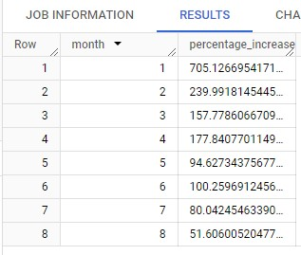

Inference: Month of January had a huge boost of 700% compared to other months

# Calculate the Total & Average value of order price for each state.

SELECT c.customer_state,

      ROUND(SUM(p.payment_value),2) AS total_order_price,

      ROUND(AVG(p.payment_value),2) AS avg_order_price

FROM target_sales_2016_2018.orders o

JOIN target_sales_2016_2018.customers c ON o.customer_id = c.customer_id

JOIN target_sales_2016_2018.payments p ON o.order_id = p.order_id

GROUP BY c.customer_state

ORDER BY c.customer_state;

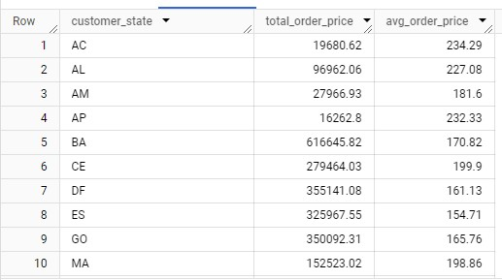

# Calculate the Total & Average value of order freight for each state.

SELECT c.customer_state,

       ROUND(SUM(oi.freight_value),2) AS total_freight_value,

       ROUND(AVG(oi.freight_value),2) AS avg_freight_value

FROM target_sales_2016_2018.orders o

JOIN target_sales_2016_2018.customers c ON o.customer_id = c.customer_id

JOIN target_sales_2016_2018.order_items oi ON oi.order_id = o.order_id

GROUP BY c.customer_state

ORDER BY c.customer_state;

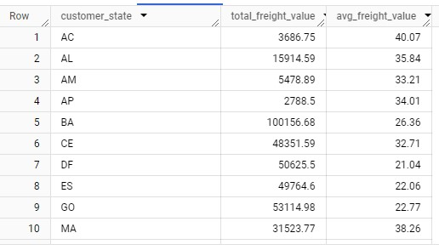

# Analysis based on sales, freight and delivery time.

# Find the no. of days taken to deliver each order from the order’s purchase date as delivery time.

# Also, calculate the difference (in days) between the estimated & actual delivery date of an order.

# Do this in a single query.

WITH delivery_times AS (

    SELECT

        order_id,

        DATE_DIFF(order_delivered_customer_date, order_purchase_timestamp, DAY) AS delivery_time,

        DATE_DIFF(order_delivered_customer_date, order_estimated_delivery_date, DAY) AS diff_estimated_delivery

    FROM

    target_sales_2016_2018.orders

    WHERE

        order_delivered_customer_date IS NOT NULL

        AND order_estimated_delivery_date IS NOT NULL

)

SELECT

    order_id,

    delivery_time,

    diff_estimated_delivery

FROM

    delivery_times;

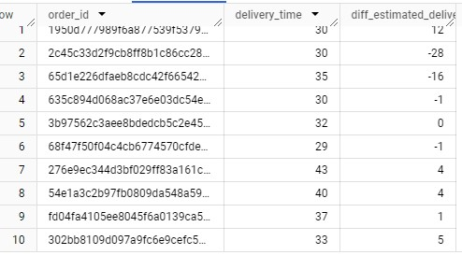

# Find out the top 5 states with the highest & lowest average freight value.

WITH state_avg_freight AS (

    SELECT

      c.customer_state,

      AVG(oi.freight_value) AS avg_freight,

    FROM target_sales_2016_2018.orders o

    JOIN target_sales_2016_2018.customers c ON o.customer_id = c.customer_id

    JOIN target_sales_2016_2018.order_items oi ON oi.order_id = o.order_id

    GROUP BY c.customer_state

), state_ranks as (

  SELECT

    customer_state,

    avg_freight,

    ROW_NUMBER() OVER (ORDER BY avg_freight DESC) AS rank_high,

    ROW_NUMBER() OVER (ORDER BY avg_freight ASC) AS rank_low

  FROM state_avg_freight

)

SELECT

 customer_state,

 avg_freight,

 rank_high

FROM state_ranks

WHERE rank_high<=5

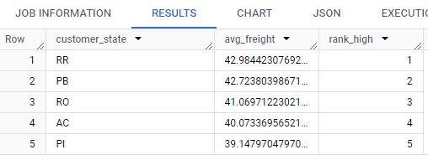

SELECT

  customer_state,

  avg_freight,

  rank_low

FROM state_ranks

WHERE rank_low<=5;

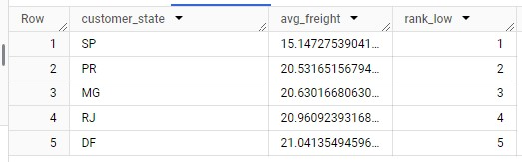

# Find out the top 5 states with the highest & lowest average delivery time.

WITH state_delivery_time AS (

    SELECT

      c.customer_state,

      AVG(DATE_DIFF(order_delivered_customer_date, order_purchase_timestamp, DAY)) AS avg_delivery_time,

      ROW_NUMBER() OVER (ORDER BY AVG(DATE_DIFF(order_delivered_customer_date, order_purchase_timestamp, DAY)) DESC) AS rank_high,

      ROW_NUMBER() OVER (ORDER BY AVG(DATE_DIFF(order_delivered_customer_date, order_purchase_timestamp, DAY)) ASC) AS rank_low

    FROM target_sales_2016_2018.orders o

    JOIN target_sales_2016_2018.customers c ON o.customer_id = c.customer_id

    WHERE order_delivered_customer_date IS NOT NULL

    GROUP BY c.customer_state

)

SELECT

    customer_state,

    avg_delivery_time,

    rank_high

FROM state_delivery_time

WHERE rank_high <= 5;

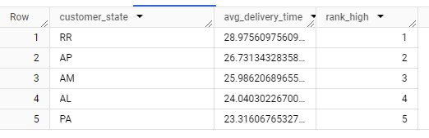

# SELECT

#    customer_state,

#    avg_delivery_time,

#    rank_low

# FROM state_delivery_time

# WHERE rank_low <= 5

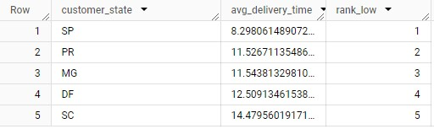

# Find out the top 5 states where the order delivery is really fast as compared to the estimated date of delivery.

# You can use the difference between the averages of actual & estimated delivery date to figure out how fast the delivery was for each state.

WITH state_delivery_speed AS (

    SELECT

        c.customer_state,

        AVG(DATE_DIFF(order_delivered_customer_date, order_estimated_delivery_date, DAY)) AS avg_delivery_speed,

        ROW_NUMBER() OVER (ORDER BY AVG(DATE_DIFF(order_delivered_customer_date, order_estimated_delivery_date, DAY)) ASC) AS rank_fastest

    FROM target_sales_2016_2018.orders o

    JOIN target_sales_2016_2018.customers c ON o.customer_id = c.customer_id

    WHERE

        order_delivered_customer_date IS NOT NULL

        AND order_estimated_delivery_date IS NOT NULL

    GROUP BY c.customer_state

)

SELECT

    customer_state,

    avg_delivery_speed,

    rank_fastest

FROM state_delivery_speed

WHERE rank_fastest <= 5;

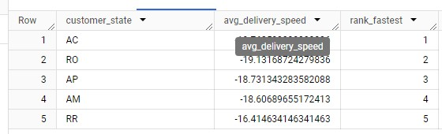

# Analysis based on the payments:

# Find the month on month no. of orders placed using different payment types.

SELECT

    EXTRACT(MONTH FROM o.order_purchase_timestamp) AS order_month,

    p.payment_type,

    COUNT(*) AS num_orders

FROM target_sales_2016_2018.orders o

JOIN target_sales_2016_2018.payments p ON o.order_id = p.order_id

GROUP BY order_month, p.payment_type

ORDER BY order_month, p.payment_type;

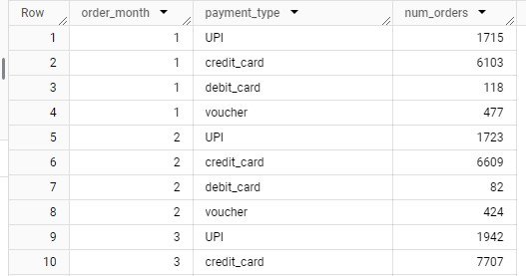

# Find the no. of orders placed on the basis of the payment installments that have been paid.

SELECT

    payment_installments,

    COUNT(*) AS num_orders

FROM target_sales_2016_2018.payments

GROUP BY payment_installments

ORDER BY payment_installments;

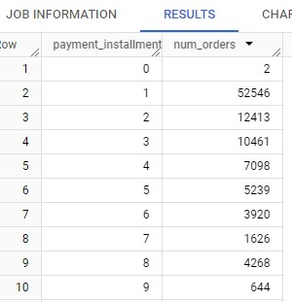

-- ___________________________________________________________________________________________________________

Actionable Insights and recommendations:

1. Introducing special offers, discounts, events, etc., in the time of peak season May-Aug.
2. Taking special care and measures to maintain the order servers in Afternoon period.
3. Designating some states like SP as high value due to large customer base and creating business plans to improve sales push in these regions.
4. Upgrading transport and infrastructure to improve the Delivery days taken for states like RR, AP, who has smaller customer base.
5. Introducing offers catered to the credit card users due to its popularity as a preferred payment method.